Juneteenth Schedule

11:00am
- meet at 5621 S. University to receive swag bags

11:30-11:45am
- Gather in Washington Park – SW corner of Payne Dr. & 57th St. (see blue circle on map)

11:45am-1:30pm
- Socially-distanced Nature Walk for reflection (small groups)

1:30-3:30pm
- Attend scheduled Juneteenth programming at the DuSable Museum of African American History (see star on map; 740 E. 56th Place)

3:30-4:00pm
- Head home or to an alternate WiFi connection

4:00-5:00pm
- Remote attendance of Angela Davis’ keynote address organized by Grad Council

What is Juneteenth?

On June 19th, 1865, more than 250,000 enslaved black people witnessed the arrival of some 2,000 Union Troops in Galveston, TX carrying the message that the Emancipation Proclamation declared all slaves free in confederate states. However, it took this message ~2.5 years after the original proclamation to reach these last slave communities. The day became known as “Juneteenth” by the newly freed people in Texas. Known also as Freedom Day, Jubilee Day, and Cel-Liberation Day, it is the oldest nationally celebrated commemoration of the ending of slavery in the USA. Long celebrated in African American communities, but largely unknown to other Americans, as of 6/17/21, this monumental event is now a federal holiday.

Why are we commemorating
Juneteenth as a cluster?

CEB students identified the formal recognition of Juneteenth as an accessible first step in a call to reflect and take action on issues of diversity and equity within our own communities, work spaces, homes, and in ourselves. It Is a day to come together for commemoration, education, and celebration, in an effort to reform and improve existing systems in the cluster. We aim to be more diverse, representative, and welcoming, to promote diversity, equity, and inclusion.

Our Nature Walk

We are informally joining with the group Outdoor Afro (outdoorafro.com), by spending at least 2.5 hours in nature to reflect upon the 2.5 years of freedom deliberately delayed for 250,000 enslaved people of Galveston, TX.

As you walk today through Washington Park, ponder the following question:
What does it mean to be free in the USA?
----------------------------------------------------------

The Walk:

- Should take ~75-90mins
- Follow path outlined in Black + arrows
- Meet at the Blue Circle ~11:30am
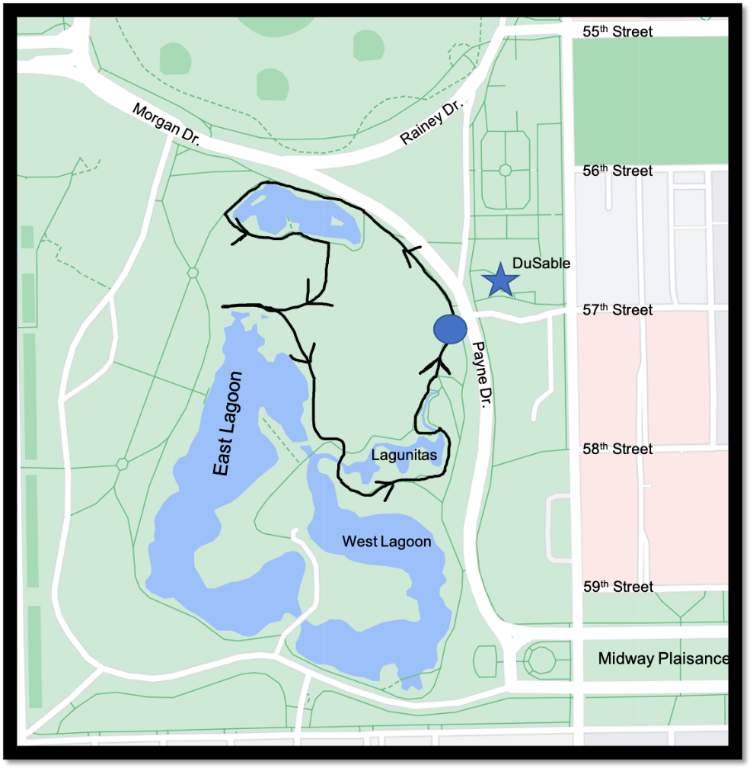

Juneteenth in the
Darwinian Sciences Cluster

2021

‘Commemorate Freedom’

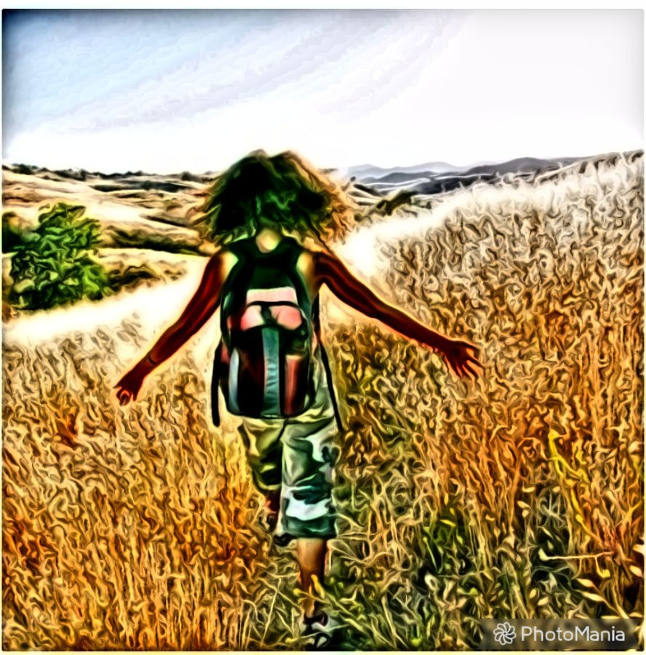

“So many of us have found in this experience of ‘sheltering in place’ that nature never closes, that it is always at the ready, and that it is ready to heal and to teach.”
-Rue Mapp

Non-exhaustive Washington Park
Species Checklist:
Plants:
-Eastern Cottonwood -Bur Oak
-White Mulberry -Ohio Buckeye
-Common Buckthorn -Northern Catalpa
-Jack-in-the-Pulpit -Yellow Iris
-Bluejacket -Red Columbine
-Eastern Shooting Star -Smooth Sumac
-Broadleaf Arrowhead -Blue Flag Iris
-Interior Sandbar Willow -Spatterdock
Lichens/Fungi
-Hooded Sunburst Lichen
-Frosted Lichens
-Dryad’s Saddle (Fungi) -Bay Polypore
-Common Ink Cap -Quince Rust
Birds:
-Baltimore Oriole -Great Blue Heron
-Orchard Oriole -Green Heron
-American Robin -Great Egret
-Gray Catbird -Downy Woodpecker
-Red-tailed Hawk -Hairy Woodpecker
-Cooper’s Hawk -Red-bellied WP
-American Kestrel -Eastern Phoebe
-Wood Duck -American Crow
-Mallard -Red-winged blackbird
-Canada goose -Common grackle
-Yellow-Billed Cuckoo -Chipping Sparrow
-Caspian Tern -Song Sparrow
-Black-crowned Night-Heron -Warbling Vireo
-Chimney Swift -House Wren
-Barn Swallow -Eastern Bluebird
-House Wren -Ring-billed Gull
-American Goldfinch -Yellow Warbler

Mammals:
-Virginia Opossum -Coyote
-Eastern Cottontail Rabbit -Meadow Vole
-Eastern Gray Squirrel
Invertebrates:
-Chinese Mystery Snail -River Snail
-Eastern Forktail -Milkweed Bug
-Margined Leatherwing Beetle -Honey Ants
-Pearl Crescent (Butterfly) -Fiery Skipper
Monarch butterfly -Carpenter Ant
-Water Skippers -Ground Crab Spider
-Yellow Garden Spider
Amphibs/Reptiles:
-Painted Turtle --Snapping Turtle
-Common Slider -Red-eared Slider
-Spiny Softshell Turtle
-Bullfrog --Leopard Frog
Fish:
-Black Bullhead Catfish -Bluegill
-Smallmouth Bass -Sunfish
-Largemouth Bass -Asian Carp

--------------------------------------------------
Apps for Species/Geology ID:
-iNaturalist -Merlin Bird ID
-Seek Plant ID -Picture Insect
-Rockd
--------------------------------------------------

Thank you for being a part this commemoration event!
-CEB DEI Committee

